Huawei FusionDirector For SCOM Plugin
1.0
 | User Guide
 | Issue | 01
 | Date | 2019-05-15

 | HUAWEI TECHNOLOGIES CO., LTD. |  | 

Copyright © Huawei Technologies Co., Ltd. 2019. All rights reserved.
No part of this document may be reproduced or transmitted in any form or by any means without prior written consent of Huawei Technologies Co., Ltd.

Trademarks and Permissions
and other Huawei trademarks are trademarks of Huawei Technologies Co., Ltd.
All other trademarks and trade names mentioned in this document are the property of their respective holders.

Notice
The purchased products, services and features are stipulated by the contract made between Huawei and the customer. All or part of the products, services and features described in this document may not be within the purchase scope or the usage scope. Unless otherwise specified in the contract, all statements, information, and recommendations in this document are provided "AS IS" without warranties, guarantees or representations of any kind, either express or implied.
The information in this document is subject to change without notice. Every effort has been made in the preparation of this document to ensure accuracy of the contents, but all statements, information, and recommendations in this document do not constitute a warranty of any kind, express or implied.

Huawei Technologies Co., Ltd.
Address: | Huawei Industrial Base  Bantian, Longgang  Shenzhen 518129  People's Republic of China
Website: | http://www.huawei.com
Email: | support@huawei.com

About This Document
Purpose
This document describes how to install and uninstall the Huawei SCOM plug-in, add and delete FusionDirector, and view Huawei server information and status, event lists, alarm lists, and server topologies by using FusionDirector For SCOM Plugin.
Intended Audience
This document is intended for:
- Technical support engineers
- System maintenance engineers
Symbol Conventions
The symbols that may be found in this document are defined as follows.
Symbol | Description
 | Indicates an imminently hazardous situation which, if not avoided, will result in death or serious injury.
 | Indicates a potentially hazardous situation which, if not avoided, could result in death or serious injury.
 | Indicates a potentially hazardous situation which, if not avoided, may result in minor or moderate injury.
 | Indicates a potentially hazardous situation which, if not avoided, could result in equipment damage, data loss, performance deterioration, or unanticipated results.  NOTICE is used to address practices not related to personal injury.
Calls attention to important information, best practices and tips.
NOTE is used to address information not related to personal injury, equipment damage, and environment deterioration.

Change History
Changes between document issues are cumulative. The latest document issue contains all the changes made in earlier issues.
Issue | Date | Description
01 | 2019-05-15 | This issue is the first official release.

Contents
About This Document ii
1 Overview 1
2 Installing and Uninstalling the Huawei SCOM Plug-in 2
2.1 Installing the Huawei SCOM Plug-in 2
2.2 Uninstalling the Huawei SCOM Plug-in 10
3 Configuring FusionDirector 16
3.1 Adding FusionDirector 16
3.2 Editing FusionDirector 19
3.3 Deleting FusionDirector 22
4 Viewing Plug-in System Information 24
4.1 Viewing the Basic Plug-in System Information and Status 24
4.2 Viewing a Plug-in System Event List 26
4.3 Viewing a Plug-in System Alarm List 28
5 Viewing Chassis Information 30
5.1 Viewing the Basic Chassis Information and Status 30
5.2 Viewing a Chassis Topology 33
5.3 Viewing a Chassis Event List 34
5.4 Viewing a Chassis Alarm List 36
6 Viewing Server Information 39
6.1 Viewing the Basic Server Information and Status 39
6.2 Viewing a Server Topology 41
6.3 Viewing a Server Event List 42
6.4 Viewing a Server Alarm List 44
6.5 Viewing Server Performance Curves 46
6.5.1 Viewing the CPU Usage 46
6.5.2 Viewing the Air Inlet Temperature 46
6.5.3 Viewing the PSU Power 47
7 FAQs 49
7.1 How Do I Manually Upload the Root Certificate and Product Certificate? 49
7.2 Viewing the Latest Topology 59
A Glossary 60

Overview
The Huawei SCOM plug-in is a plug-in integrated in the System Center Operations Manager (SCOM for short) software and used for Huawei server management. By adding FusionDirector, it can monitor the health status and alarm information of Huawei servers. A maximum of 3000 servers can be monitored. Table 1-1 lists the servers supported by the Huawei SCOM plug-in.
You can implement the following functions by using the Huawei SCOM plug-in:
- View the information of servers and chassis.
- View the health status of servers and chassis.
- View the alarm information and event information of servers and chassis.
- View the topologies of servers and chassis.
- View the performance curves of servers.
                - Supported servers
Type | Server
Server | 1288H V5
Server | 2288 V5
Server | 2288H V5
Server | 2488 V5
Server | 2488H V5
Server | CH121 V3
Server | CH242 V3
Server | CH121 V5
Server | CH242 V5
Server | RH2288H V3
Chassis | E9000 (MM920)

Installing and Uninstalling the Huawei SCOM Plug-in
2.1 Installing the Huawei SCOM Plug-in
2.2 Uninstalling the Huawei SCOM Plug-in

Installing the Huawei SCOM Plug-in
Prerequisites
- SCOM 2012 R2 or SCOM 2016 has been installed on the SCOM server.
- .Net Framework 4.0 or later has been installed on the SCOM server.
- FusionDirector 1.5.0.061 has been installed on the SCOM server.
Procedure
            - Download the Huawei SCOM plug-in installation package of the latest version from the GitHub website, for example, Huawei_FusionDirector_For_SCOM_Plugin_X.X.X.X.zip.
            - Upload the Huawei SCOM plug-in installation package to the SCOM server.
            - Log in to the SCOM server.
            - Decompress the Huawei SCOM plug-in installation package.
Obtain the installation application, for example, Huawei_FusionDirector_For_SCOM_Plugin_1.0.11.257.exe.
            - Double-click Huawei_FusionDirector_For_SCOM_Plugin_1.0.11.257.exe.
The Installer Language window is displayed, as shown in Figure 1-1.
              - Installer Language
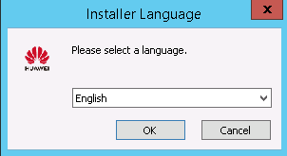

            - Select English, and click OK.
The Huawei Fusion Director For SCOM plugin 1.0.11 Setup window is displayed, as shown in Figure 1-1.
              - Huawei Fusion Director For SCOM plugin 1.0.11 Setup
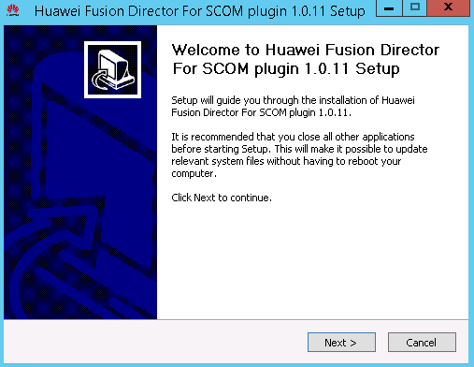

            - Click Next.
The Choose Install Location window is displayed, as shown in Figure 1-1.
              - Choose Install Location
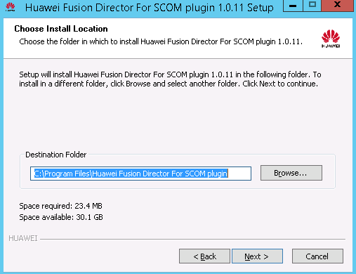

            - Retain the default installation path or click Browse to change the installation path, and click Next.
The Select features to install window is displayed, as shown in Figure 1-1.
              - Select features to install
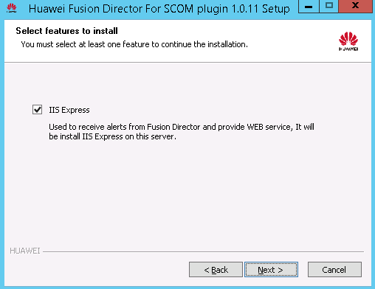

            - IIS Express is selected by default. Click Next.
The IP/Port Configuration window is displayed, as shown in Figure 1-1.
              - IP/Port Configuration
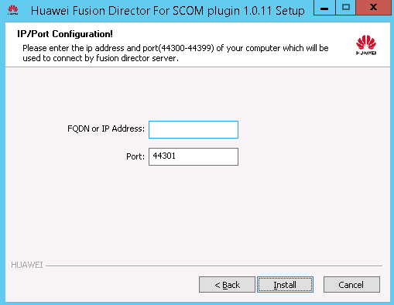

            - Enter the FQND or IP address and port number of the SCOM server that is used to connect to FusionDirector. (The port number ranges from 44300 to 44399. You are advised to retain the default value 44301.) Click Install.
The Huawei SCOM plug-in installation starts, as shown in Figure 1-1.
              - Installing the Huawei SCOM plug-in
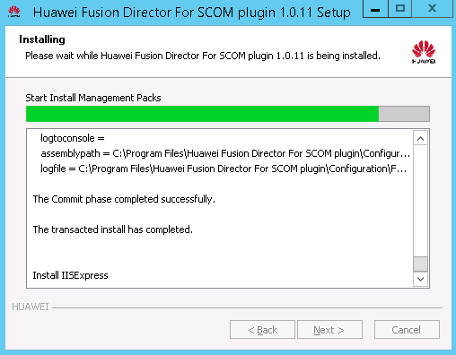

After the installation is complete, the Completing Huawei Fusion Director For SCOM plugin 1.0.11 Setup window is displayed, as shown in Figure 1-2.
              - Completing Huawei Fusion Director For SCOM plugin 1.0.11 Setup
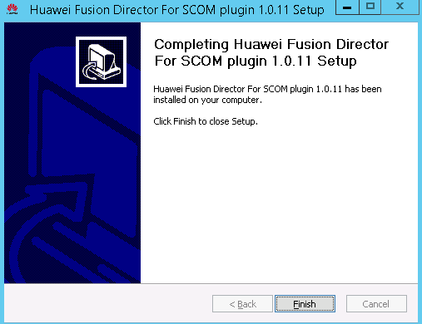

            - Click Finish.
The Huawei SCOM plug-in installation is complete.
            - Choose Start > > Operations Console.
The SCOM main window is displayed, as shown in Figure 1-1.
              - SCOM main window
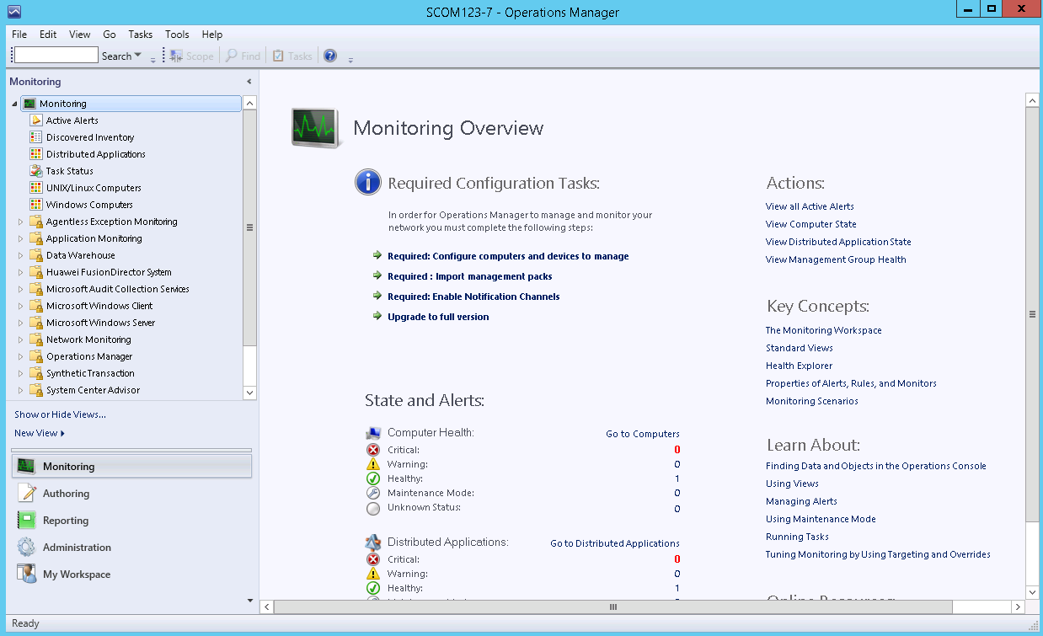

            - Choose Administration > Management Packs.
The Management Packs window is displayed, as shown in Figure 1-1.
              - Management Packs
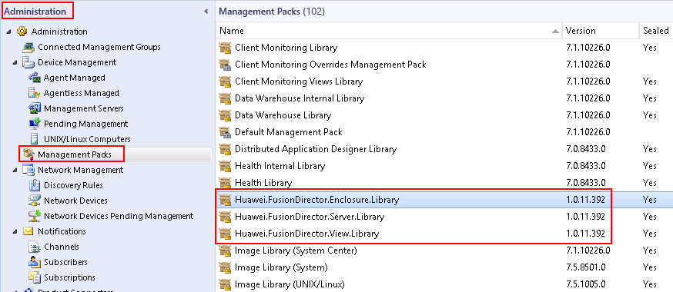

After the Huawei SCOM plug-in is successfully installed, the Manage Package (MP) packages in the red box are displayed in the Management Packs window.
After the MP packages are successfully installed, the nodes in the red box are displayed in the SCOM main window, as shown in Figure 1-2.
              - SCOM main window
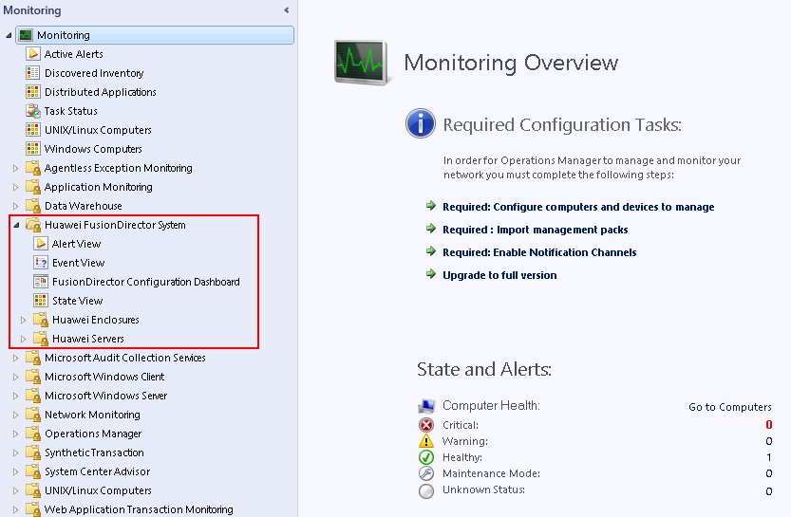

----End

Uninstalling the Huawei SCOM Plug-in
Prerequisites
You need to close the SCOM window before uninstalling the Huawei SCOM plug-in.
Uninstalling the Huawei SCOM Plug-in from the Control Panel
            - Choose Start > Control Panel > Programs and Features > Uninstall a program.
The Uninstall or change a program window is displayed, as shown in Figure 1-1.
              - Uninstall or change a program
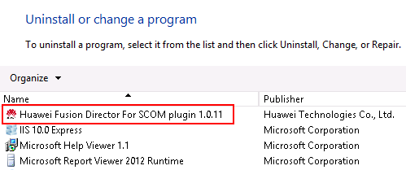

            - Double-click the Huawei SCOM plug-in (for example, Huawei Fusion Director For SCOM plugin 1.0.11).
A confirmation dialog box is displayed, as shown in Figure 1-1.
              - Dialog box
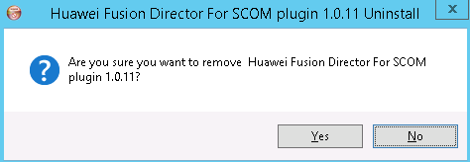

            - Click Yes.
The dialog box asking you whether to uninstall IIS Express is displayed, as shown in Figure 1-1.
              - Dialog box
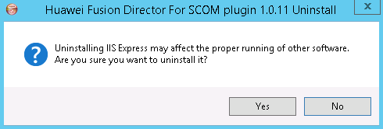

- IIS Express is responsible for the communication between the plug-in and FusionDirector. Uninstalling IIS Express may affect the proper running of other software. Exercise caution when performing this operation.
- If you uninstall IIS Express, it will be reinstalled when you install the Huawei SCOM plug-in again.
- If IIS Express needs to be uninstalled, click Yes.
- If IIS Express does not need to be uninstalled, click No.
            - Click Yes or No.
The Huawei SCOM plug-in uninstallation starts, as shown in Figure 1-1.
              - Uninstalling the Huawei SCOM plug-in
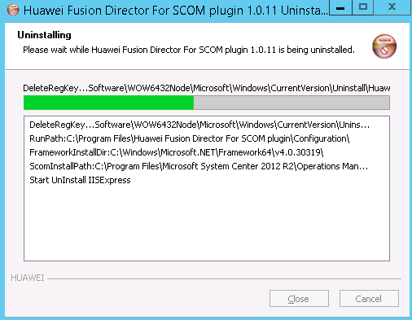

After the uninstallation is complete, the dialog box shown in Figure 1-2 is displayed.
              - Uninstallation completed
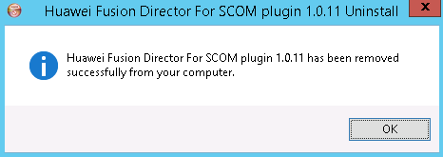

            - Click OK.
The Huawei SCOM plug-in is uninstalled.
----End
Uninstalling the Huawei SCOM Plug-in from the Installation Directory
            - Go to the installation directory of the Huawei SCOM plug-in (C:\Program Files\Huawei Fusion Director For SCOM plugin by default), as shown in Figure 1-1.
              - Installation directory of the Huawei SCOM plug-in
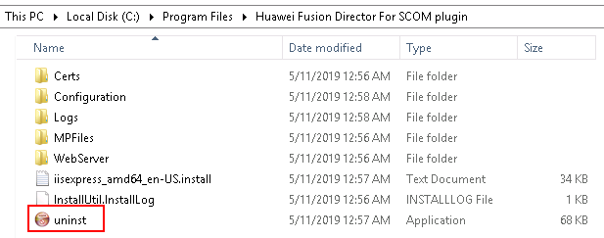

            - Double-click uninst.
A confirmation dialog box is displayed, as shown in Figure 1-1.
              - Dialog box

            - Click Yes.
The dialog box asking you whether to uninstall IIS Express is displayed, as shown in Figure 1-1.
              - Dialog box

- IIS Express is responsible for the communication between the plug-in and FusionDirector. Uninstalling IIS Express may affect the proper running of other software. Exercise caution when performing this operation.
- If you uninstall IIS Express, it will be reinstalled when you install the Huawei SCOM plug-in again.
- If IIS Express needs to be uninstalled, click Yes.
- If IIS Express does not need to be uninstalled, click No.
            - Click Yes or No.
The Huawei SCOM plug-in uninstallation starts, as shown in Figure 1-1.
              - Uninstalling the Huawei SCOM plug-in

After the uninstallation is complete, the dialog box shown in Figure 1-2 is displayed.
              - Uninstallation completed

            - Click OK.
The Huawei SCOM plug-in is uninstalled.
----End

Configuring FusionDirector
3.1 Adding FusionDirector
3.2 Editing FusionDirector
3.3 Deleting FusionDirector

Adding FusionDirector
A maximum of 10 FusionDirector instances can be added.
            - Choose Start > > Operations Console.
The SCOM main window is displayed, as shown in Figure 1-1.
              - SCOM main window

            - Choose Monitoring > Huawei FusionDirector System > FusionDirector Configure View.
The FusionDirector Configure Dashboard window is displayed, as shown in Figure 1-1.
              - FusionDirector Configure Dashboard
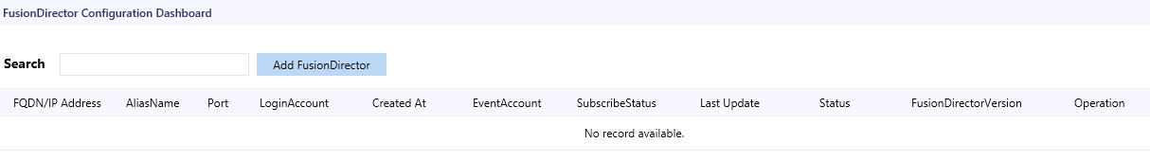

            - Click Add FusionDirector.
The Add FusionDirector dialog box is displayed, as shown in Figure 1-1.
              - Add FusionDirector
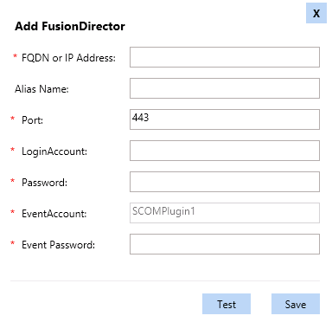

Table 1-1 describes the parameters in this dialog box.
                - Parameter description
Parameter | Description | Value | Mandatory
FQDN or IP Address | FQDN or IP address of FusionDirector. | The IP address format is XXX.XXX.XXX.XXX. Each X must be an integer. | Yes
Alias Name | Customized FusionDirector name. | The value is a string of 1 to 100 characters, including letters, digits, underscores (_), hyphens (-), and dots (.). | No
Port | FusionDirector port number. | The default value is 443. | Yes
LoginAccount | FusionDirector user name. | The default value is rootRedfish. | Yes
Password | FusionDirector password. | The default value is Machine@123. | Yes
Event Account | Alarm service account. | The value is automatically generated by the system. | Yes
Event Password | Alarm service password. | The password contains 8 to 32 characters, including uppercase letters, lowercase letters, digits, and special characters.  Special characters include '~!@$%^&*()-_=+|[{}];:'"",<>/?. | Yes

            - Enter FusionDirector information, and click Test to test whether the SCOM server can connect to FusionDirector.
If the test is successful, "Connect successfully" is displayed, as shown in Figure 1-1. If the test fails, the failure cause is displayed. Modify FusionDirector information as prompted.
              - Successful test
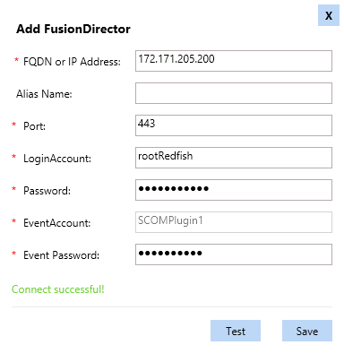

            - Click Save.
The FusionDirector is added successfully, as shown in Figure 1-1.
              - FusionDirector added successfully
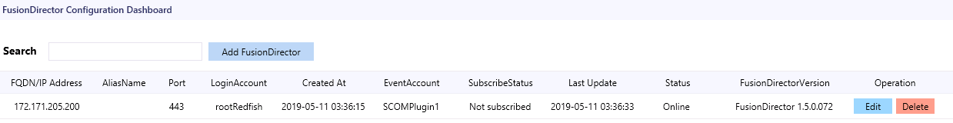

----End

Editing FusionDirector
            - Choose Start > > Operations Console.
The SCOM main window is displayed, as shown in Figure 1-1.
              - SCOM main window

            - Choose Monitoring > Huawei FusionDirector System > FusionDirector Configure Dashboard.
The FusionDirector Configure Dashboard window is displayed, as shown in Figure 1-1.
              - FusionDirector Configure Dashboard

If the FusionDirector information is empty, no FusionDirector is added.
            - In the Operation column, click Edit.
The Edit FusionDirector dialog box is displayed, as shown in Figure 1-1.
              - Edit FusionDirector
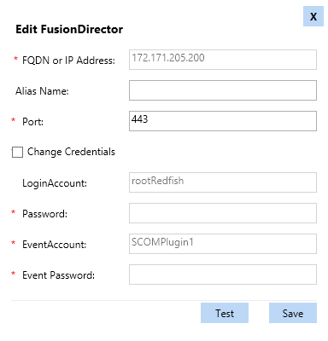

            - Edit the FusionDirector information according to Table 1-1, and click Save.

- The FusionDirector IP address cannot be modified.
- You can change the FusionDirector user name and password only after selecting Change Credentials. After changing the user name and password, click Test.
The FusionDirector is successfully edited, as shown in Figure 1-1. In this window, you can check whether the modified information is consistent with the target.
              - Modified FusionDirector information
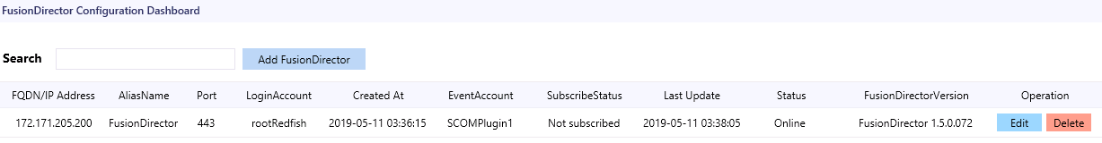

----End

Deleting FusionDirector
            - Choose Start > > Operations Console.
The SCOM main window is displayed, as shown in Figure 1-1.
              - SCOM main window

            - Choose Monitoring > Huawei FusionDirector System > FusionDirector Configure Dashboard.
The FusionDirector Configure Dashboard window is displayed, as shown in Figure 1-1.
              - FusionDirector Configure Dashboard

If the FusionDirector information is empty, no FusionDirector is added.
            - In the Operation column, click Delete.
The Delete FusionDirector dialog box is displayed, as shown in Figure 1-1.
              - Delete FusionDirector
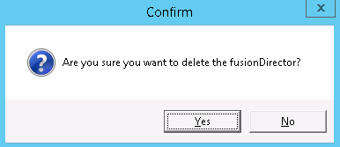

            - Click OK.
The FusionDirector is successfully deleted, as shown in Figure 1-1. In this window, you can check whether the target FusionDirector is deleted.
              - FusionDirector deleted successfully

----End

Viewing Plug-in System Information
4.1 Viewing the Basic Plug-in System Information and Status
4.2 Viewing a Plug-in System Event List
4.3 Viewing a Plug-in System Alarm List

Viewing the Basic Plug-in System Information and Status
            - Choose Start > > Operations Console.
The SCOM main window is displayed.
            - Choose Monitoring > Huawei FusionDirector System > State View.
The State View window is displayed, as shown in Figure 1-1.
              - State View
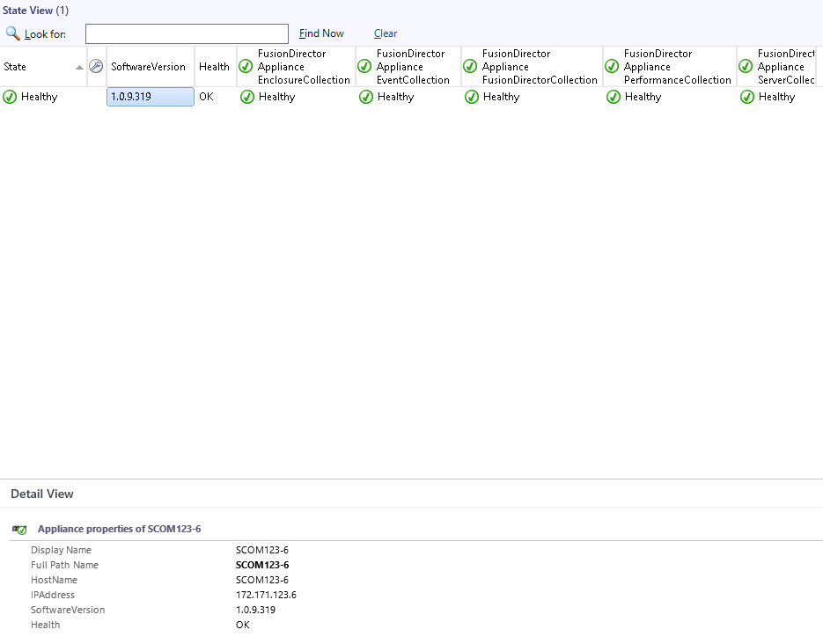

Each column in this window displays the running status of each function of the plug-in.
- FusionDirector Appliance EnclosureCollection: chassis monitoring function
- FusionDirector Appliance EventCollection: event monitoring function
- FusionDirector Appliance FusionDirectorCollection: FusionDirector monitoring function
- FusionDirector Appliance PerformanceCollection: performance curve monitoring function
- FusionDirector Appliance ServerCollection: server monitoring function
You can click anywhere in the row of the plug-in in the State View area to view details about the plug-in in the Detail View area.
The component health status is described as follows:
- : healthy
- : minor alarms
- : major or critical alarms
            - Set the parameters to be displayed.
- Right-click a plug-in name or monitoring status and choose Personalize View... from the shortcut menu.
The Personalize View window is displayed, as shown in Figure 1-1.
              - Personalize View
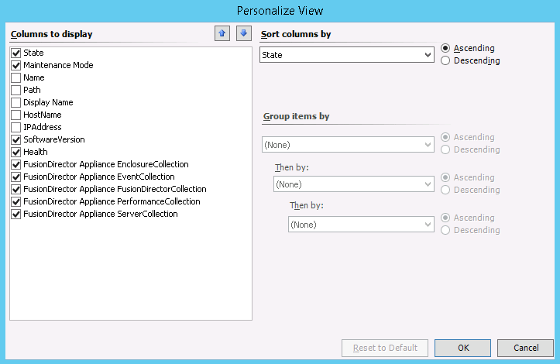

- Select parameters to be viewed and click OK.
The parameters to be viewed are modified successfully.
----End

Viewing a Plug-in System Event List
            - Choose Start > > Operations Console.
The SCOM main window is displayed.
            - Choose Monitoring > Huawei FusionDirector System > Event View.
The Event View window is displayed. You can click the event to be viewed to view the details of the event in the Event Data area, as shown in Figure 1-1.
              - Event View
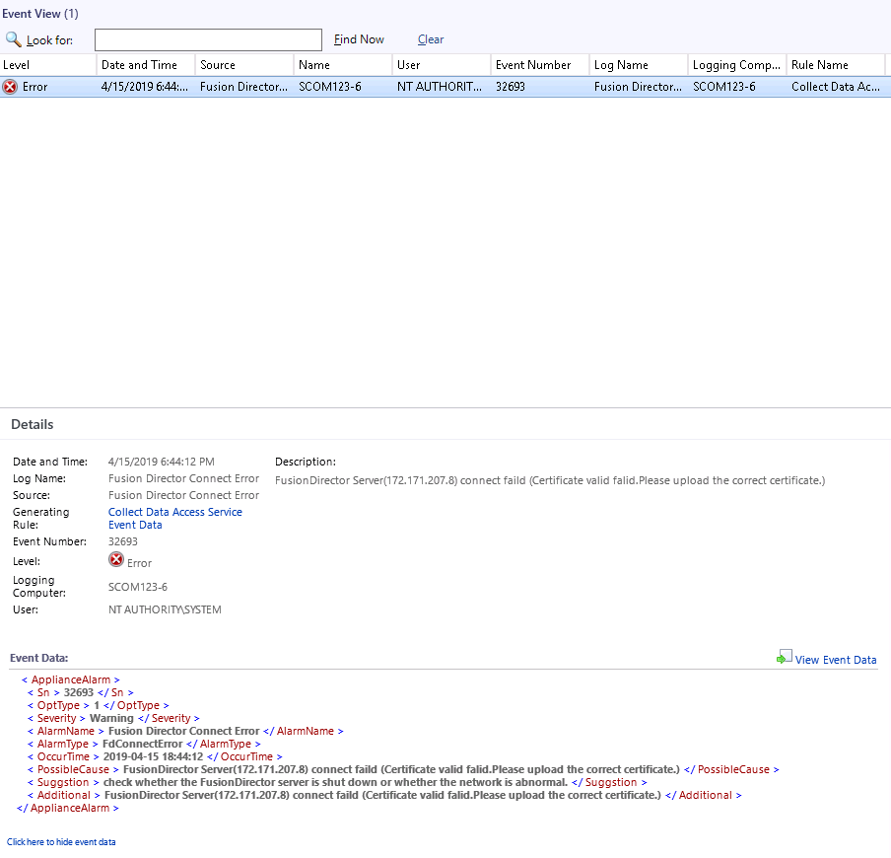

Table 1-1 describes the parameters.
                - Parameter description
Parameter | Description
Level | Event type. The options are as follows:  - Information: running event  - Warning: minor alarm  - Error: major or critical alarm
Date and Time | Date and time when the event is generated.
Source | Event source, which is the component where the event is generated.
Name | Device where the event is generated.
User | Current user.
Event Number | Event number.
Log Name | Event name.
Logging Computer | Current login device.
Rule Name | Rule name.

----End

Viewing a Plug-in System Alarm List
            - Choose Start > > Operations Console.
The SCOM main window is displayed.
            - Choose Monitoring > Huawei FusionDirector System > Alert View.
The Alert View window is displayed. You can click an alarm to view its details, as shown in Figure 1-1.
              - Alert View
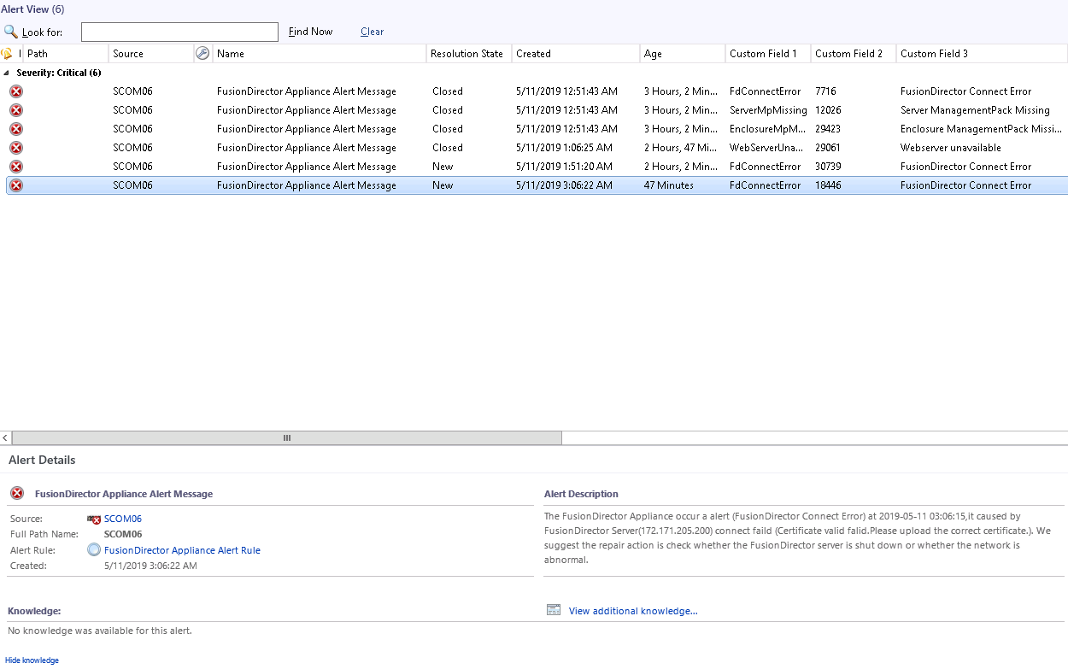

Table 1-1 describes the parameters.
                - Parameter description
Parameter | Description
lcon | Alarm type. The options are as follows:  - Warning: minor alarm  - Error: major or critical alarm
Path | Sensor that generates the alarm.
Source | Device where the alarm is generated.
Maintenance Mode | Maintenance mode.
Name | Alarm name.
Resolution State | Handling status.
Created | Time when the alarm is generated.
Age | Duration of the alarm.
Owner | Owner.
Priority | Priority.
Latency | Latency.
Description | Alarm description.
Class | Alarm type.
Time in State | Alarm duration.
Repeat Count | Number of repeated occurrence times.
Custom Field 1 | Alarm type.
Custom Field 2 | Alarm code.
Custom Field 3 | Alarm name.
Custom Field 4 | Possible cause.
Custom Field 5 | Remarks.
Custom Field 6 | Alarm clearance suggestion.
Custom Field 7 | Alarm occurrence time.
----End

Viewing Chassis Information
5.1 Viewing the Basic Chassis Information and Status
5.2 Viewing a Chassis Topology
5.3 Viewing a Chassis Event List
5.4 Viewing a Chassis Alarm List

Viewing the Basic Chassis Information and Status
            - Choose Start > > Operations Console.
The SCOM main window is displayed.
            - Choose Monitoring > Huawei FusionDirector System > Huawei Enclosures > State View.
The State View window is displayed, as shown in Figure 1-1. In this window, the managed chassis are displayed in different rows and monitoring parameters of chassis are displayed in different columns.
              - State View
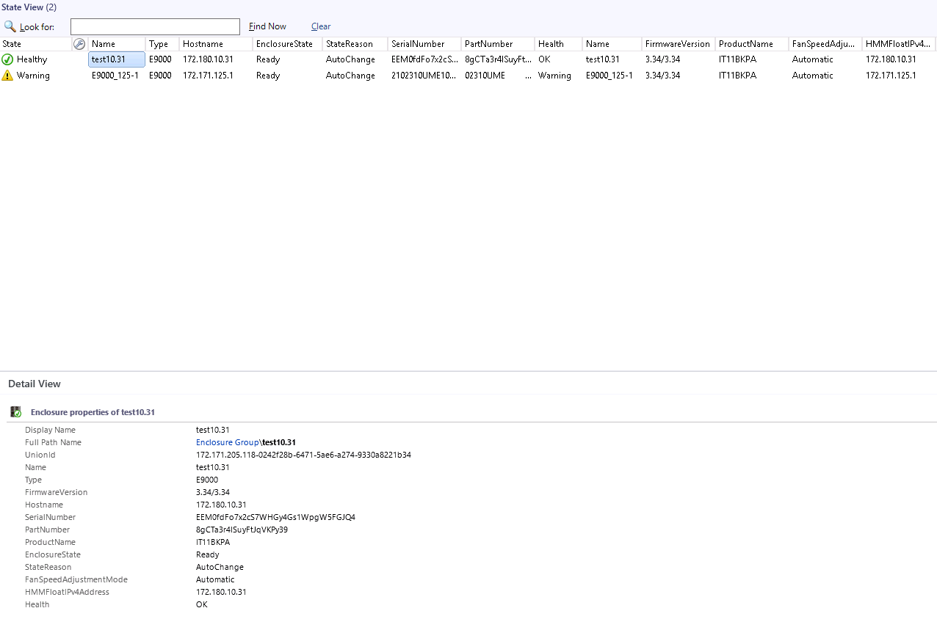

In the State View area, you can click any position in the row of a chassis to view details about the chassis in the Detail View area.
The chassis health status is described as follows:
- : healthy
- : minor alarms
- : major or critical alarms
            - Set the parameters to be displayed.
- Right-click a chassis name and choose Personalize View... from the shortcut menu.
The Personalize View window is displayed, as shown in Figure 1-1.
              - Personalize View
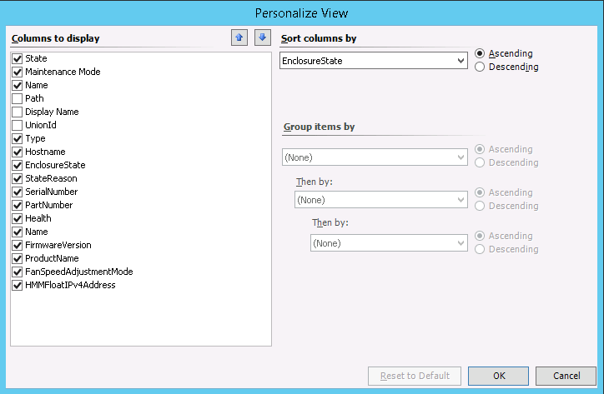

- Select parameters to be viewed and click OK.
The parameters to be viewed are modified successfully.
Table 1-1 describes the parameters that can be viewed by the Huawei SCOM plug-in.
                - Components and parameters that can be viewed
Parameter | Description
State | Chassis presence status.
Name | Server name.
Type | Server model.
Hostname | Host name.
StateReason | Reason of the chassis presence status.
SerialNumber | Serial number.
PartNumber | Component number.
Health | Chassis health status.
FirmwareVersion | HMM version.
ProductName | Product name.
FanSpeedAdjustmentMode | Fan speed adjustment mode.
HMMFloatIPv4Address | HMM floating IP address.

----End

Viewing a Chassis Topology
            - Choose Start > > Operations Console.
The SCOM main window is displayed.
            - Choose Monitoring > Huawei FusionDirector System > Huawei Enclosures > Diagram View.
The Diagram View window is displayed, as shown in Figure 1-1.
              - Diagram View
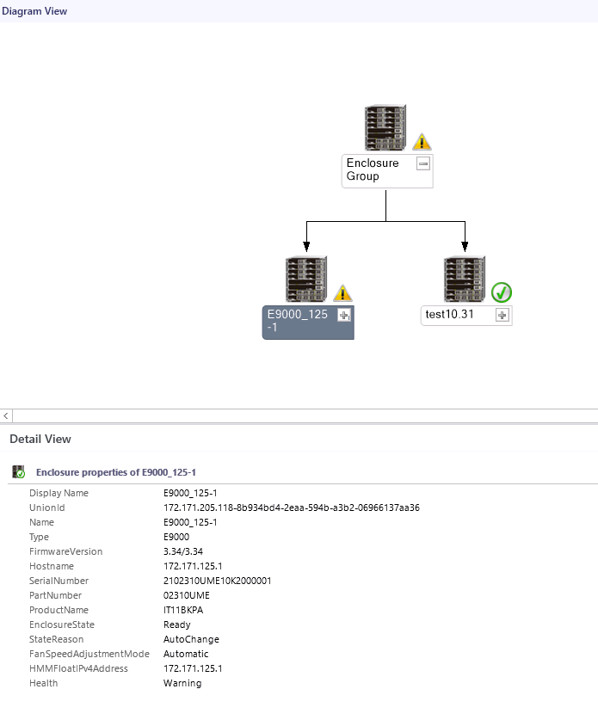

----End

Viewing a Chassis Event List
            - Choose Start > > Operations Console.
The SCOM main window is displayed.
            - Choose Monitoring > Huawei FusionDirector System > Huawei Enclosures > Event View.
In the Event View window that is displayed, click the event to be viewed. You can view the details of the event in the Event Data area, as shown in Figure 1-1.
The FusionDirector that is added for the first time synchronously displays historical events that are not cleared.
              - Event View
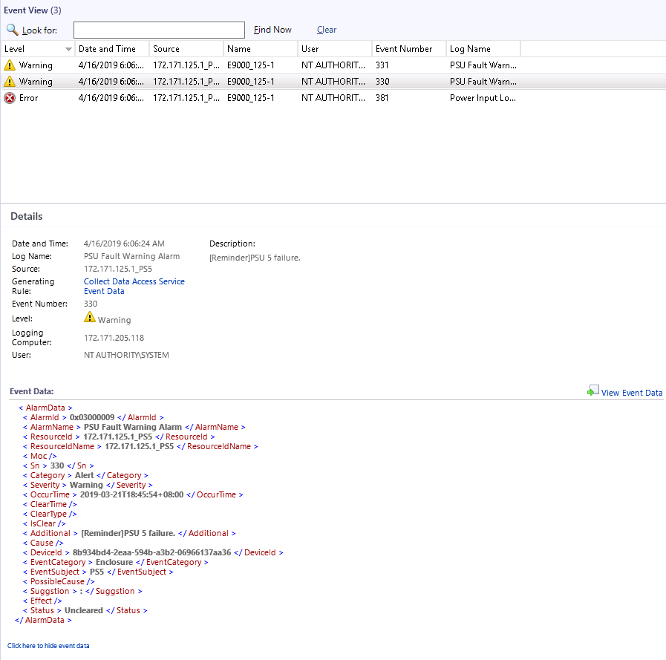

Table 1-1 describes the parameters.
                - Parameter description
Parameter | Description
Level | Event type. The options are as follows:  - Information: running event  - Warning: minor alarm  - Error: major or critical alarm
Date and Time | Date and time when the event is generated.
Source | Event source, which is the component where the event is generated.
Name | Device where the event is generated.
User | Current user.
Event Number | Event number.
Log Name | Event name.
Logging Computer | Current login device.
Rule Name | Rule name.

----End

Viewing a Chassis Alarm List
            - Choose Start > > Operations Console.
The SCOM main window is displayed.
            - Choose Monitoring > Huawei FusionDirector System > Huawei Enclosures > Alert View.
In the Alert View window that is displayed, click an alarm to view its details, as shown in Figure 1-1.
The FusionDirector that is added for the first time synchronously displays historical alarms that are not cleared.
              - Alert View
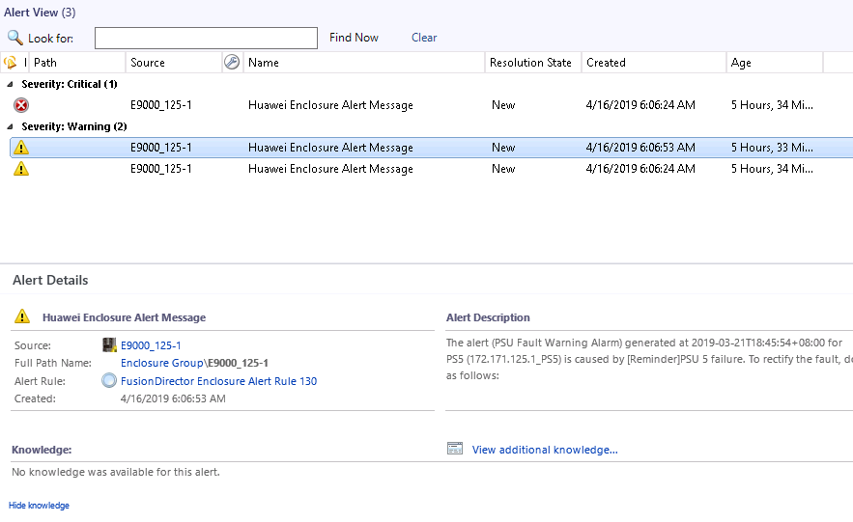

Table 1-1 describes the parameters.
                - Parameter description
Parameter | Description
lcon | Alarm type. The options are as follows:  - Warning: minor alarm  - Error: major or critical alarm
Path | Sensor that generates the alarm.
Source | Device where the alarm is generated.
Maintenance Mode | Maintenance mode.
Name | Alarm name.
Resolution State | Handling status.
Created | Time when the alarm is generated.
Age | Duration of the alarm.
Owner | Owner.
Priority | Priority.
Latency | Latency.
Description | Alarm description.
Class | Alarm type.
Time in State | Alarm duration.
Custom Field 1 | Alarm object identifier.
Custom Field 2 | Alarm code.
Custom Field 3 | Alarm name.
Custom Field 4 | Alarm source.
Custom Field 5 | Alarm serial number.
Custom Field 6 | Alarm description.
Custom Field 7 | Alarm clearance suggestion.
Custom Field 8 | Time when the alarm is generated.
Custom Field 9 | Possible cause of the alarm.
Custom Field 10 | Alarm impact.
Repeat Count | Number of repeated occurrence times.
----End

Viewing Server Information
6.1 Viewing the Basic Server Information and Status
6.2 Viewing a Server Topology
6.3 Viewing a Server Event List
6.4 Viewing a Server Alarm List
6.5 Viewing Server Performance Curves

Viewing the Basic Server Information and Status
            - Choose Start > > Operations Console.
The SCOM main window is displayed.
            - Choose Monitoring > Huawei FusionDirector System > Huawei Servers > State View.
The State View window is displayed, as shown in Figure 1-1. In this window, the managed servers are displayed in different rows and status monitoring parameters of monitored components on each server are displayed in different columns.
              - State View
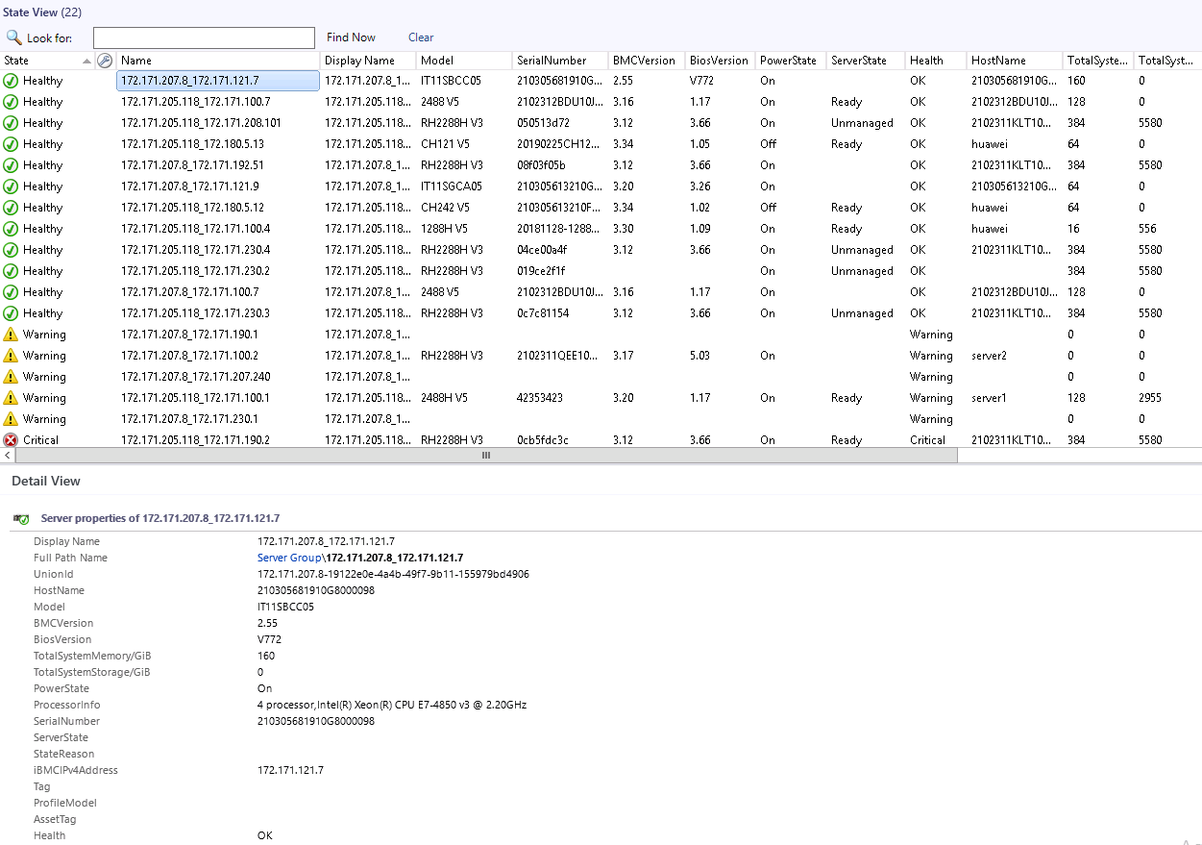

In the State View area, you can click any position in the row of a server to view details about the server in the Detail View area.
The server health status is described as follows:
- : healthy
- : minor alarms
- : major or critical alarms
            - Set the parameters to be displayed. For details, see Step 3 in 5.1 Viewing the Basic Chassis Information and Status.
Table 1-1 describes server parameters that can be monitored by the Huawei SCOM plug-in.
                - Parameter description
Parameter | Description
State | Server presence status.
Model | Server model.
SerialNumber | Serial number.
Tag | Server tag.
AssetTag | Asset tag.
BMCVersion | iBMC version.
BiosVersion | BIOS version.
PowerState | Power status.
Health | Server health status.
HostName | Host name.
TotalSystemMemoryGiB | Memory size.
TotalSystemStorageGiB | Storage size.
ProcessorInfo | CPU information.
StateReason | Reason of the server presence status.
iBMCIPv4Address | iBMC IP address.
ProfileModel | Configuration file type.
UUID | UUID

----End

Viewing a Server Topology
            - Choose Start > > Operations Console.
The SCOM main window is displayed.
            - Choose Monitoring > Huawei FusionDirector System > Huawei Servers > Diagram View.
The Diagram View window is displayed, as shown in Figure 1-1.
              - Diagram View
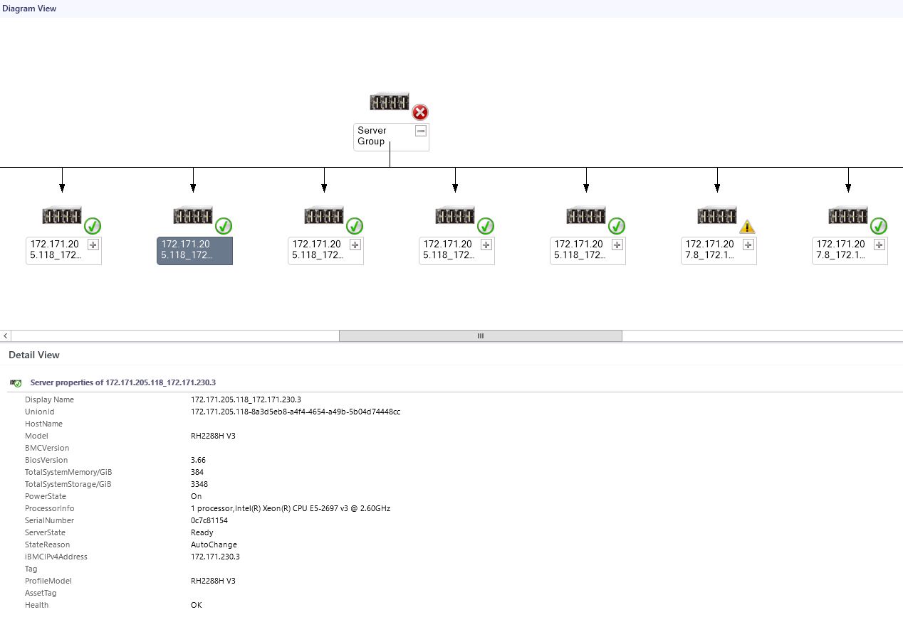

----End

Viewing a Server Event List
            - Choose Start > > Operations Console.
The SCOM main window is displayed.
            - Choose Monitoring > Huawei FusionDirector System > Huawei Servers > Event View.
In the Event View window that is displayed, click the event to be viewed. You can view the details of the event in the Event Data area, as shown in Figure 1-1.
The FusionDirector that is added for the first time synchronously displays historical events that are not cleared.
              - Event View
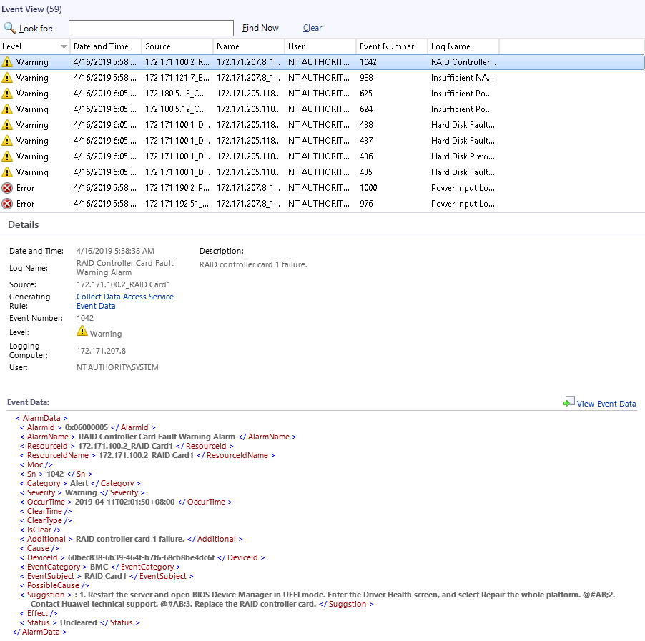

Table 1-1 describes the parameters.
                - Parameter description
Parameter | Description
Level | Event type. The options are as follows:  - Information: running event  - Warning: minor alarm  - Error: major or critical alarm
Date and Time | Date and time when the event is generated.
Source | Event source, which is the component where the event is generated.
Name | Device where the event is generated.
User | Current user.
Event Number | Event number.
Log Name | Event name.
Logging Computer | Current login device.
Rule Name | Rule name.

----End

Viewing a Server Alarm List
            - Choose Start > > Operations Console.
The SCOM main window is displayed.
            - Choose Monitoring > Huawei FusionDirector System > Huawei Servers > Alert View.
In the Alert View window that is displayed, click an alarm to view its details, as shown in Figure 1-1.
The FusionDirector that is added for the first time synchronously displays historical alarms that are not cleared.
              - Alert View
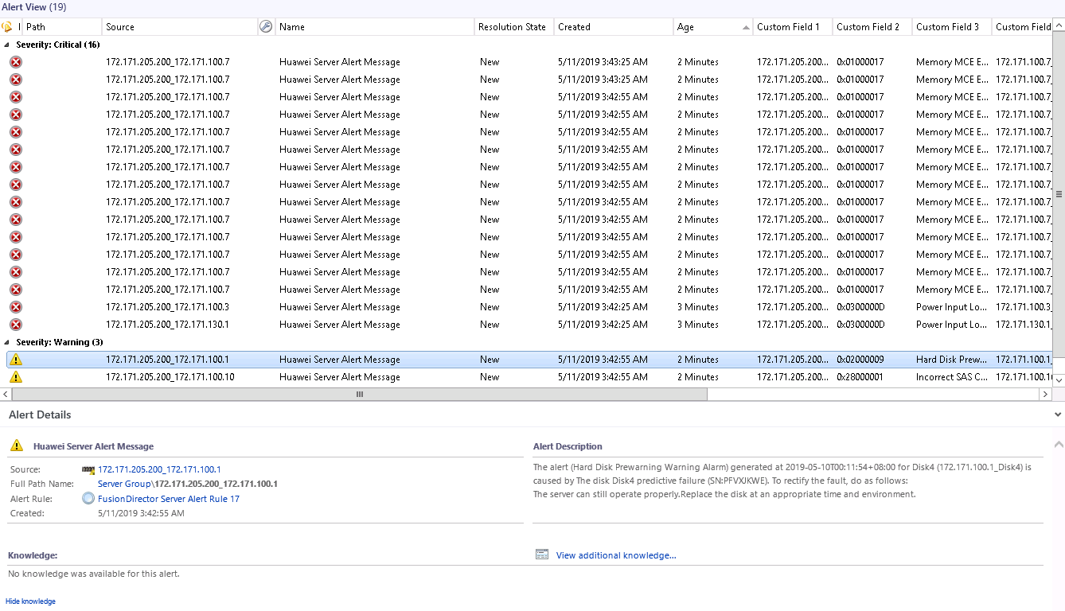

Table 1-1 describes the parameters.
                - Parameter description
Parameter | Description
lcon | Alarm type. The options are as follows:  - Warning: minor alarm  - Error: major or critical alarm
Path | Sensor that generates the alarm.
Source | Device where the alarm is generated.
Maintenance Mode | Maintenance mode.
Name | Alarm name.
Resolution State | Handling status.
Created | Time when the alarm is generated.
Age | Duration of the alarm.
Owner | Owner.
Priority | Priority.
Latency | Latency.
Description | Alarm description.
Class | Alarm type.
Time in State | Alarm duration.
Custom Field 1 | Alarm object identifier.
Custom Field 2 | Alarm code.
Custom Field 3 | Alarm name.
Custom Field 4 | Alarm source.
Custom Field 5 | Alarm serial number.
Custom Field 6 | Alarm description.
Custom Field 7 | Alarm clearance suggestion.
Custom Field 8 | Time when the alarm is generated.
Custom Field 9 | Possible cause of the alarm.
Custom Field 10 | Alarm impact.
Repeat Count | Number of repeated occurrence times.

----End

Viewing Server Performance Curves
You can view performance curves only of servers whose ServerState is Ready.

Viewing the CPU Usage
            - Choose Start > > Operations Console.
The SCOM main window is displayed.
            - Choose Monitoring > Huawei FusionDirector System > Huawei Servers > Performance View > CPU Usage(%).
The CPU Usage(%) window is displayed, as shown in Figure 1-1.
              - CPU Usage(%)
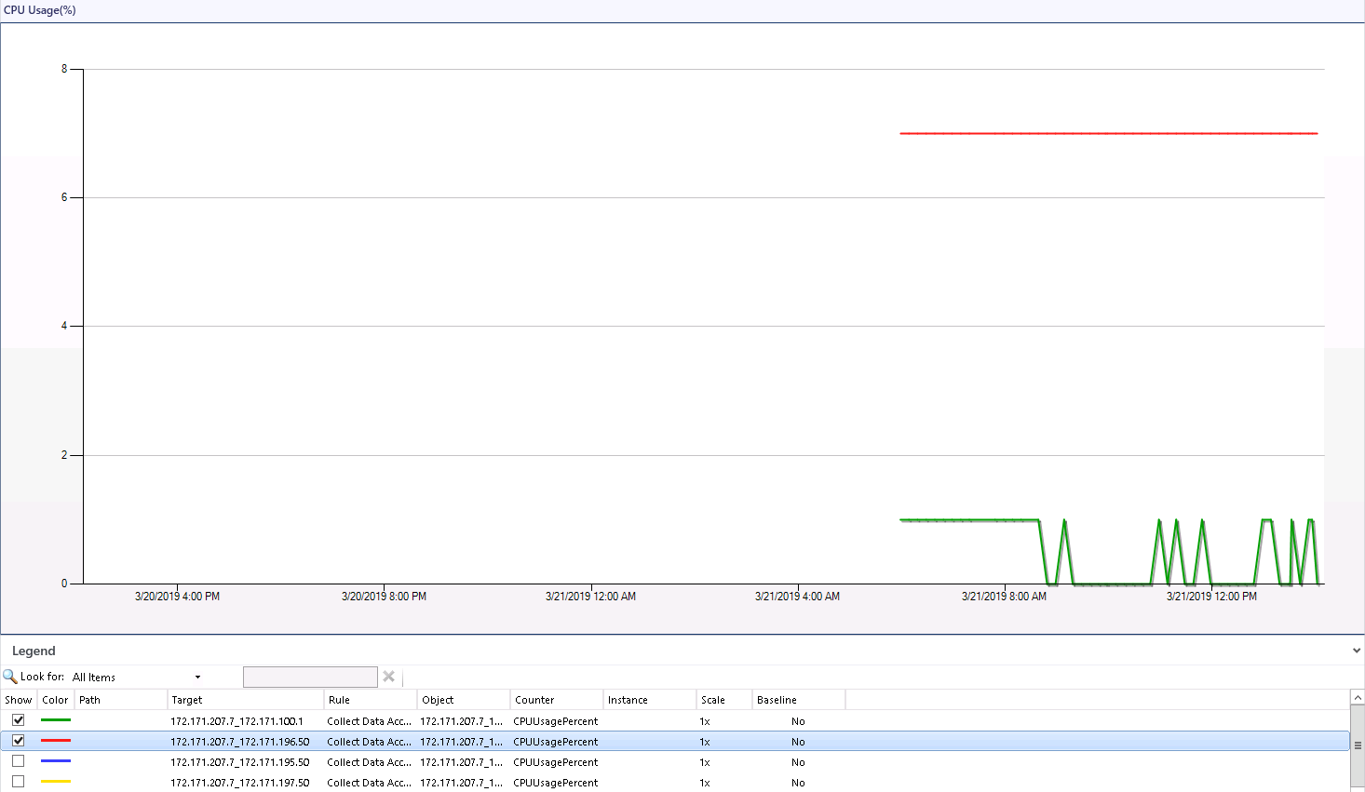

            - Select servers in the Legend area to view the CPU usage curves of the servers.
----End

Viewing the Air Inlet Temperature
            - Choose Start > > Operations Console.
The SCOM main window is displayed.
            - Choose Monitoring > Huawei FusionDirector System > Huawei Servers > Performance View > Inlet Temp(Centigrade).
The Inlet Temp(Centigrade) window is displayed, as shown in Figure 1-1.
              - Inlet Temp(Centigrade)
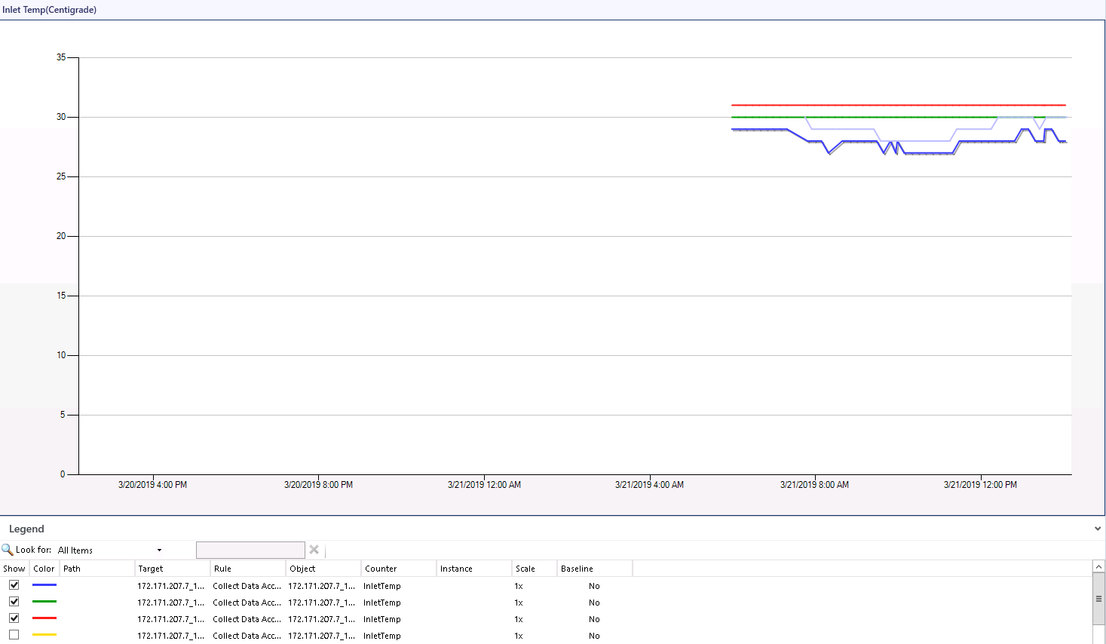

            - Select servers in the Legend area to view the air inlet temperature curves of the servers.
----End

Viewing the PSU Power
            - Choose Start > > Operations Console.
The SCOM main window is displayed.
            - Choose Monitoring > Huawei FusionDirector System > Huawei Servers > Performance View > Power Consumed(Watts).
The Power Consumed(Watts) window is displayed, as shown in Figure 1-1.
              - Power Consumed(Watts)
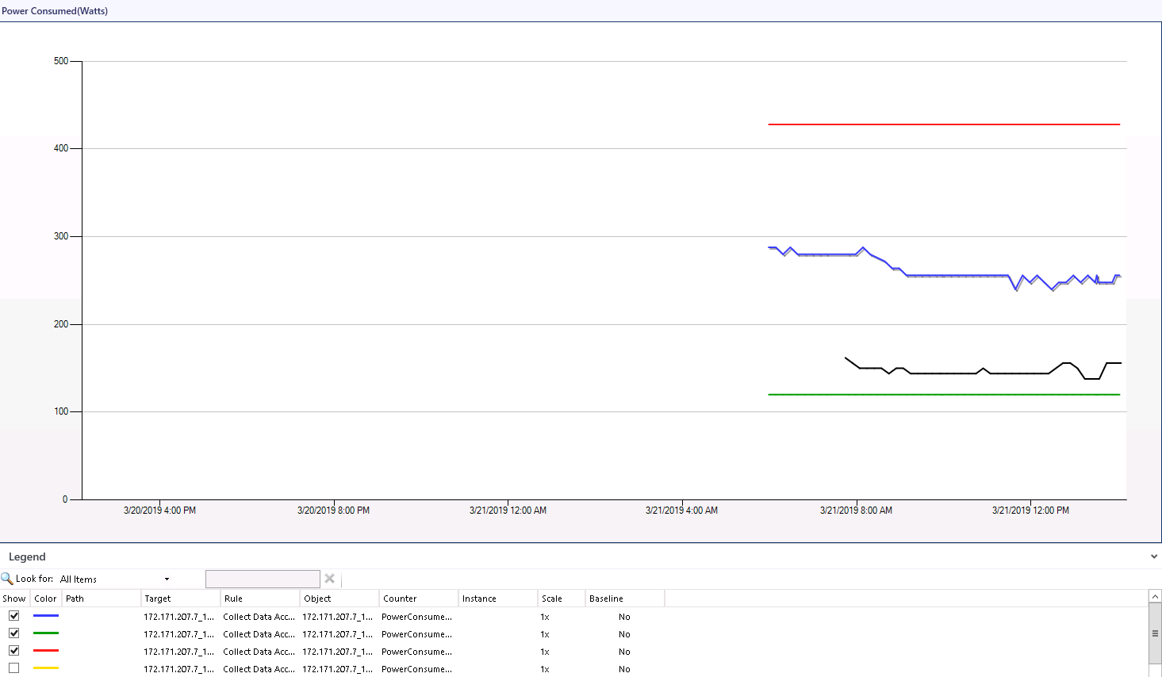

            - Select servers in the Legend area to view the PSU power curves of the servers.
----End

FAQs
7.1 How Do I Manually Upload the Root Certificate and Product Certificate?
7.2 Viewing the Latest Topology

How Do I Manually Upload the Root Certificate and Product Certificate?
Uploading the Root Certificate
            - Go to the Certs folder in the installation directory (C:\Program Files\Huawei Fusion Director For SCOM plugin\Certs by default) of the Huawei SCOM plug-in, as shown in Figure 1-1.
              - Certs folder
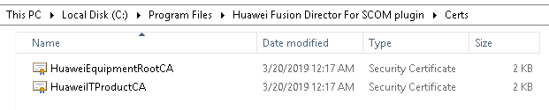

            - Double-click HuaweiEquipmentRootCA.
The Certificate window is displayed, as shown in Figure 1-1.
              - Certificate
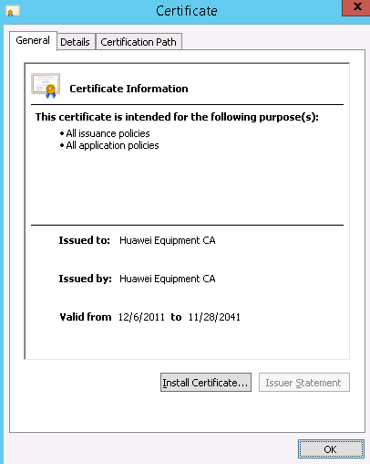

            - Click Install Certificate....
The Certificate Import Wizard window is displayed, as shown in Figure 1-1.
              - Certificate Import Wizard
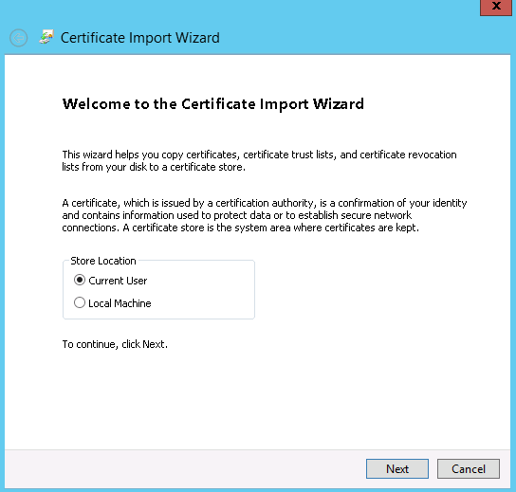

            - Select Local Machine and click Next.
The Certificate Store window is displayed, as shown in Figure 1-1.
              - Certificate Stone
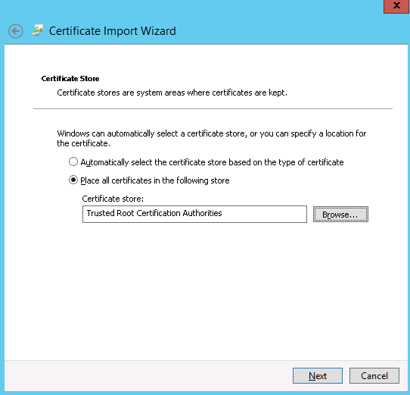

            - Select Place all Certificates in following store.
            - Click Browse…, select Trusted Root Certification Authorities, and click Next.
The Completing the Certificate Import Wizard window is displayed, as shown in Figure 1-1.
              - Completing the Certificate Import Wizard
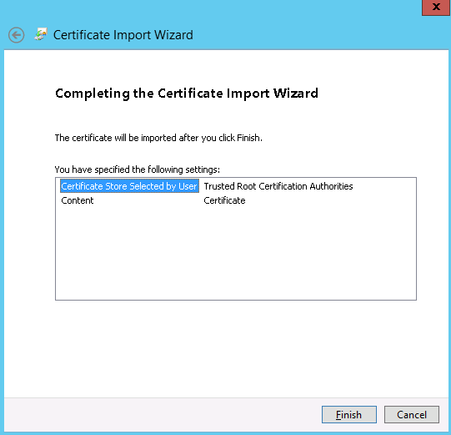

            - Click Finish.
A dialog box indicating import success is displayed, as shown in Figure 1-1.
              - Import success
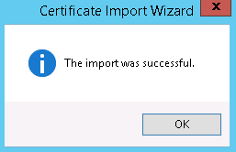

            - Click OK.
            - On the Figure 1-1 page, click OK. The certificate is imported.
----End
Uploading the Product Certificate
            - Go to the Certs folder in the installation directory (C:\Program Files\Huawei Fusion Director For SCOM plugin\Certs by default) of the Huawei SCOM plug-in, as shown in Figure 1-1.
              - Certs folder

            - Double-click HuaweiITProductCA.
The Certificate window is displayed, as shown in Figure 1-1.
              - Certificate
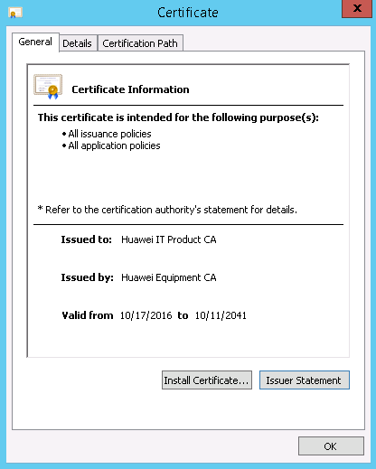

            - Click Install Certificate....
The Certificate Import Wizard window is displayed, as shown in Figure 1-1.
              - Certificate Import Wizard

            - Select Local Machine and click Next.
The Certificate Store window is displayed, as shown in Figure 1-1.
              - Certificate Store
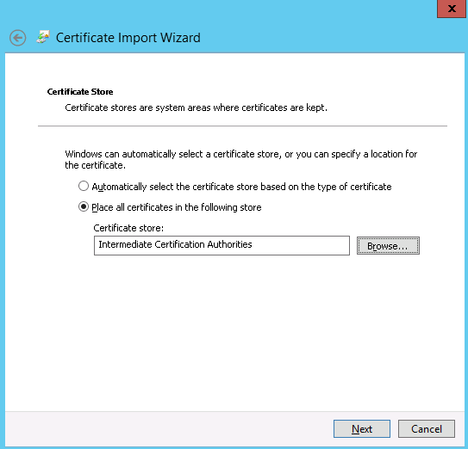

            - Select Place all Certificates in following store.
            - Click Browse…, select Intermediate Certification Authorities, and click Next.
The Completing the Certificate Import Wizard window is displayed, as shown in Figure 1-1.
              - Completing the Certificate Import Wizard
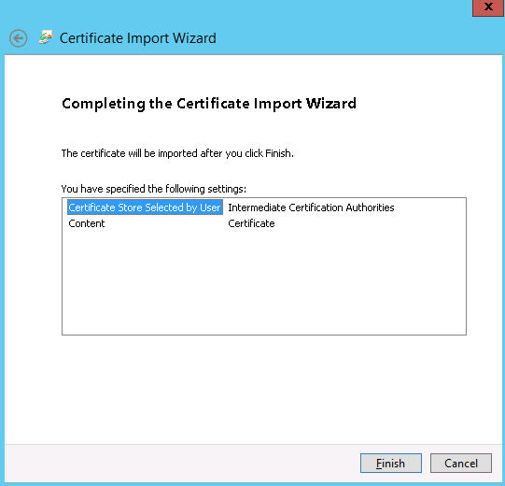

            - Click Finish.
A dialog box indicating import success is displayed, as shown in Figure 1-1.
              - Import success

            - Click OK.
            - On the Figure 1-1 page, click OK. The certificate is imported.
----End

Viewing the Latest Topology
            - Open the CLI of the SCOM server.
            - In the CLI, enter the SCOM installation path (C:\Program Files\System Center Operations Manager 2012\Console).
            - Run the following command to refresh the SCOM window:
            - Microsoft.EnterpriseManagement.Monitoring.Console.exe" /clearcache
----End
- Glossary
E
eSight | eSight is a platform related to Huawei server management.

N
NetFramework | Microsoft .NET Framework is a new hosting code programming model used for Windows. It combines powerful functions with new technologies to construct applications with excellent user experience, implement seamless communications across technical boundaries, and support various service processes.

S
SCOM | System Center Operation Manager (SCOM) refers to the Microsoft system center operation manager. SCOM monitors servers, application systems, and clients in the network. It provides a GUI for administrators to monitor faults and alarms of target computers.

